# TechWiz4

# Project Report SoccerVerse Website Design and Development SRS

**Batch No: *T5.2306.E1***

**Mentor:*****Lê Tuấn Xuyên***

**Group Name: FireAlarm**

|  |  |  |
| --- | --- | --- |
| **Order:** | **Full name** | **Roll No.** |
| *1.* | Lê Vinh Chí | Student1477477 |
| *2.* | Tạ Quốc Thạnh | Student1470287 |
| *3.* | Trần Minh Quang | Student1477192 |
| *4.* | Nguyễn Thanh Hậu | Student1477167 |
| *5.* | Lê Trọng Nghĩa | Student1477172 |
| *6.* | Nguyễn Hoàng Anh Tú | Student1470285 |

***Month****: 08* ***Year****: 2023*

Table of Content

TechWiz4 1

Project Report SoccerVerse Website Design and Development SRS 1

I. Acknowledgement 3

II. Synopsis 4

III. Problem Definition 5

IV. Design Specifications 5

V. Diagram 7

VI. Source Code 8

VII. Screenshots 9

VIII. Test Data 13

# Acknowledgement

As we understand that the TechWiz is a step-by-step learning environment that closely simulates the classroom and Lab-based learning environment into actual implementation. It is a project implementation at your fingertips!! An electronic, live juncture on the machine that allows you to.

Practice step by step i.e. laddered approach.

* Usage of certain utilities in applications designed by user.
* Single program to unified code leading to a complete application.
* Learn implementation of concepts in a phased manner.
* Enhance skills and add value.
* Work on real-life projects.

Give a real-life scenario and help to create applications that are more complicated and useful mentoring through email support.

First, I would like to thank India Aptech for allowing my team to work on this fantastic competition. We had a great experience this time.

Next, we would like to express my special thanks to our mentor, Mr Xuyen for the time and effort that he provided throughout the project. His helpful advice and suggestions were beneficial to us during the completion of the project.

Besides several mistakes we made in the project, we hope to have more opportunities to widen our knowledge in the web-developing world.

We will try to continue to learn and improve ourselves even more in the future.

Yours Sincerely,

Team FireAlarm

# Synopsis

The Objective of this program we aim is to give a sample project to work on real- life projects. These applications help us build a larger more robust application.

The objective is not only to teach us HTML/JavaScript but also to provide us with a real-life scenario and help us create basic website using the tools.

Hence, we can revise the chapters before we start with the project.

This project is meant for students like us who have completed the module of HTML5. These programs should be done in the Lab sessions with the assistance of the faculty if required.

It is very essential for us that will have a clear understanding of the subject. We think we should go through the project and solve the assignments as per the requirements given.

## Problem Definition

**Requirement Specification:**

The purpose of this project is to present a detailed description of the Website SoccerVerse that will provide users with a centralized platform to access comprehensive soccer-related information.

The team must build the Website that has well feature, interface and easy to use for user. Containt up-dated content or news that can be able to attract the football fans.

The portal will be designed as a responsive website with a set of pages and menus that represent a choice of activities to be performed. The pages, menus, and other visual elements must be designed in a visually appealing manner with attractive fonts, colors, and animations. All of these should also be laid out in a responsive manner.

The team with all members who were joined APTECH from Jun 2023 had a limited knowledge of HTML & Javascript faced difficulties to satisfy the requirements such as Json, fetch…

The visual of website with limited data so viewer will see duplication in football player cards.

## Design Specifications

**Hardware/ software requirement:**

Software:

Technologies to be used:

1. Frontend: HTML5, CSS3, Bootstrap (optional), JavaScript, Figma Toolkit,

jQuery, AngularJS/Angular 9/ReactJS, and XML

2. Data Store: JSON/TXT

Hardware:

Intel Core i5 Processor or higher 8 GB RAM or higher

Color SVGA

500 GB Hard Disk space Mouse Keyboard

**Portal Functionality:**

The portal can source data either through hardcoding or retrieval from JSON/TXT files. The ensuing functional requisites of the portal encompass:

**Soccer Match Insights:**

The website should furnish comprehensive details on soccer games, comprising match timetables, scores, team lineups, and match statistics.

Users ought to have the ability to peruse forthcoming matches and access past match outcomes.

**Player Showcases:**

The website should showcase galleries dedicated to soccer players.

Users should be granted access to player profiles, encompassing their biographies, statistics, and imagery.

**Elite 10 Rankings:**

The website should showcase the preeminent ten high-scoring players or teams, predicated on specific criteria like goals achieved or earned points.

Users should be empowered to scrutinize the rankings and navigate to individual player or team profiles.

**Classification, Exploration, and Refinement:**

Users should be furnished with the capability to categorize soccer game data, player showcases, and elite 10 rankings based on sundry parameters such as date, team, player name, or score.

A search bar should be integrated, permitting users to look up distinct soccer matches, players, or teams.

Users should be afforded the option to winnow soccer match data by specific criteria like tournaments, leagues, or match types.

**Input and Assessment:**

A feedback menu should be provided to facilitate users in furnishing feedback regarding the website via a designated feedback form.

**Get in Touch:**

A "Contact Us" menu should be available, allowing users to establish contact with the creators of the website. Contact information, such as an email ID, can be showcased here.

## Diagram

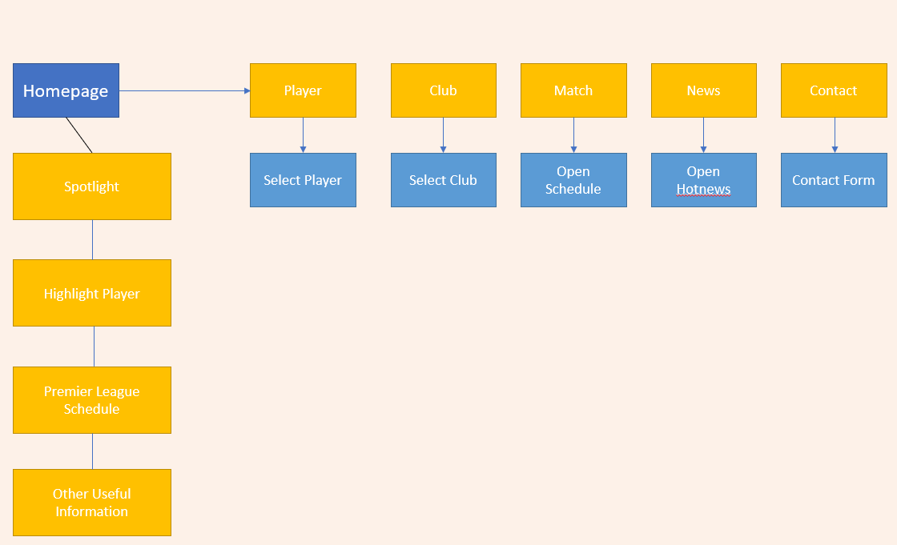

## Source Code

Please kindly refer attachment for full source code.

## Screenshots

1. **Home Page**

**Description Home Page:**

* Header (Logo, social media channel, search).
* Nav Bar (Home, Player, Club, Match, News, Contact)
* Spotlight area (Casadeu topics, hot news, youtube video)

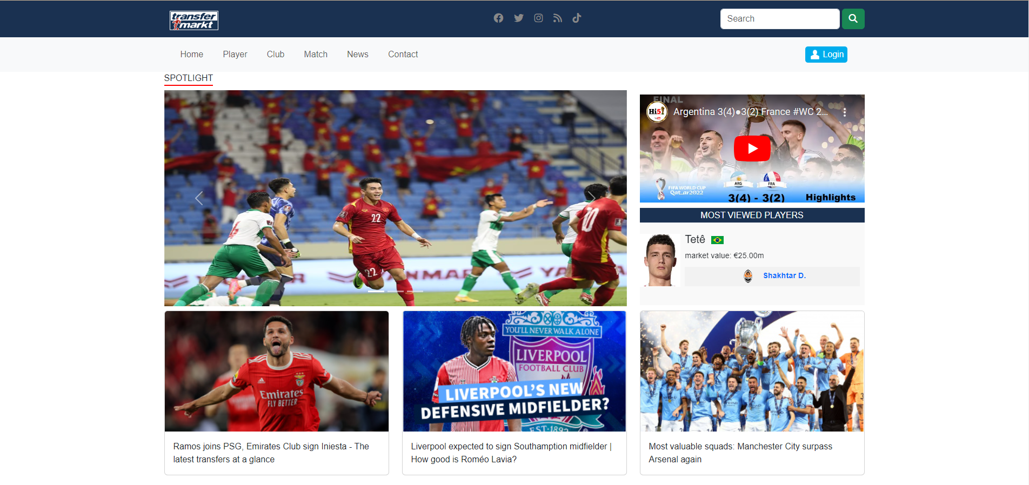

* High light players (Soft by score)

* Premier League Schedule – Match of the day

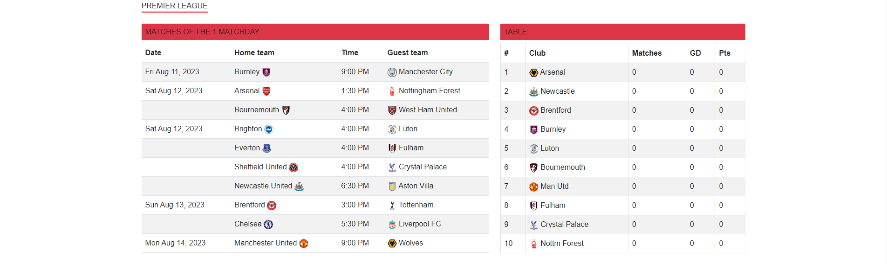

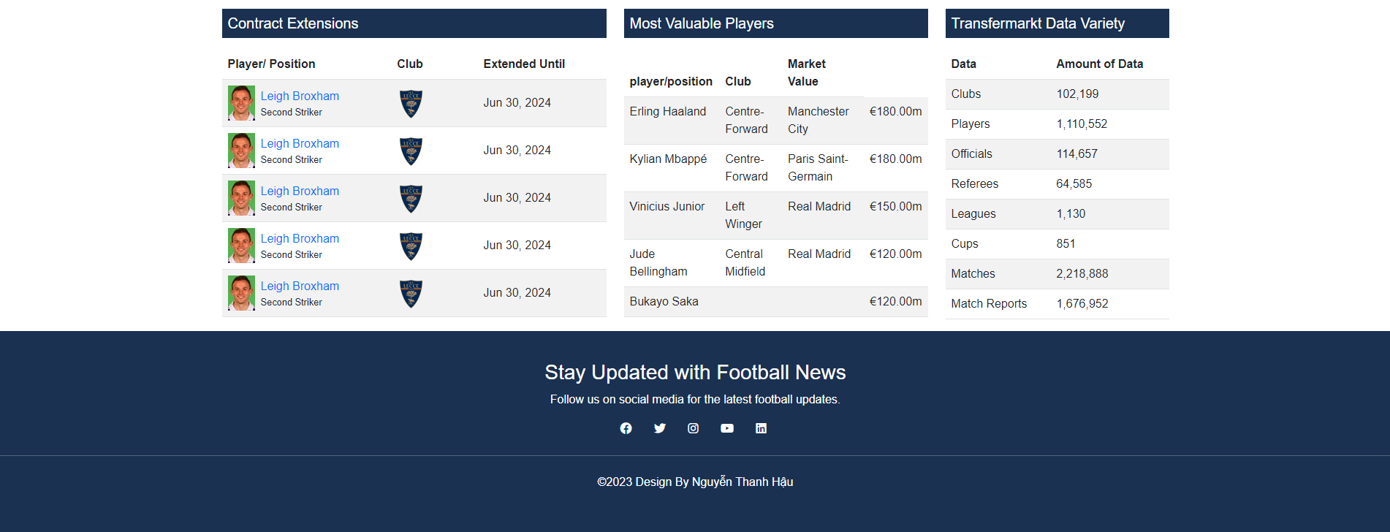

1. **Menu**

* Home: Go back home.
* Players: Go to players profile.
* Club: Go to Club Page.
* Matches: Go to Match Schedule.
* News : Open news page.
* Contact: Open form to send request.



1. **Player**

* Show details of players, search player to view.
* Use search to find player name.
* *(Data duplicate due to hard code).*

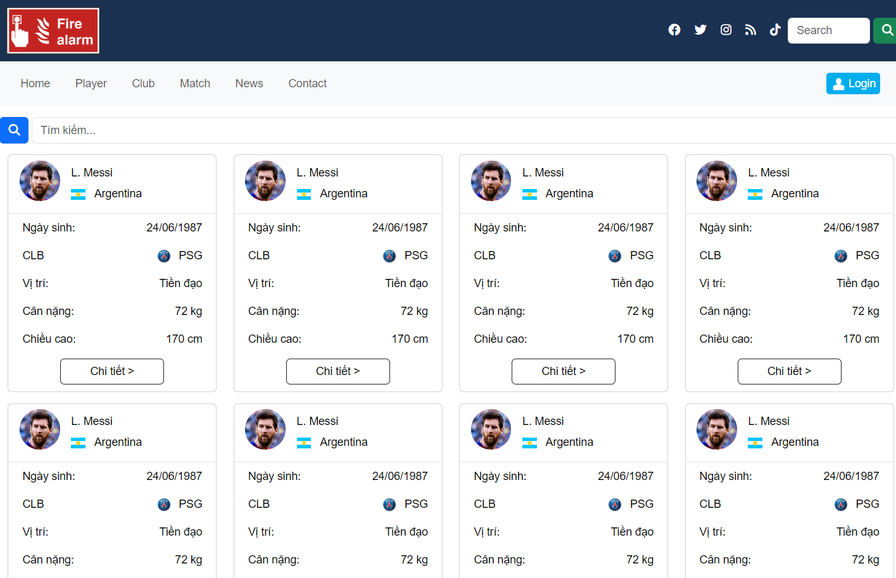

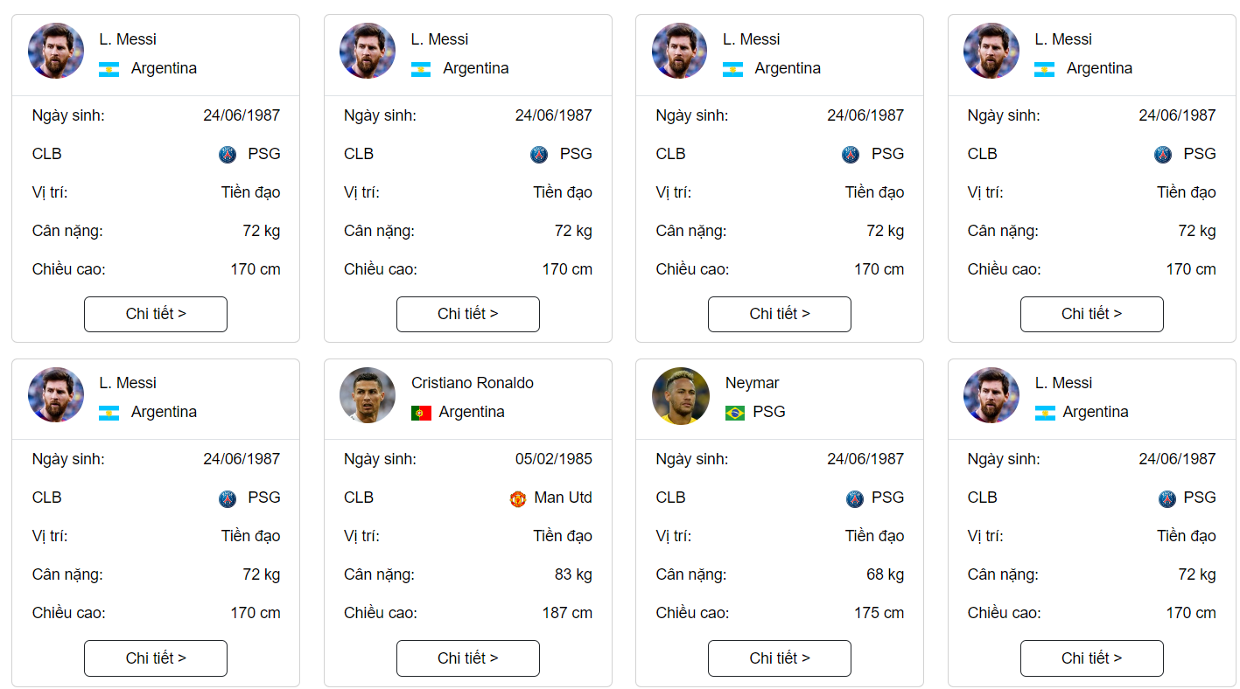

1. **Club**

* Show details of a club, select club to view.
* List player of selected club (New data limited due to hardcode).

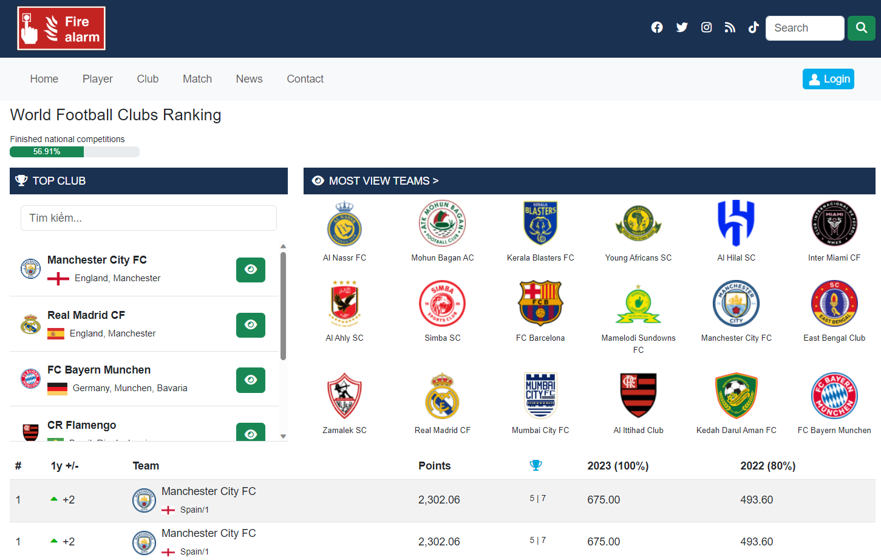

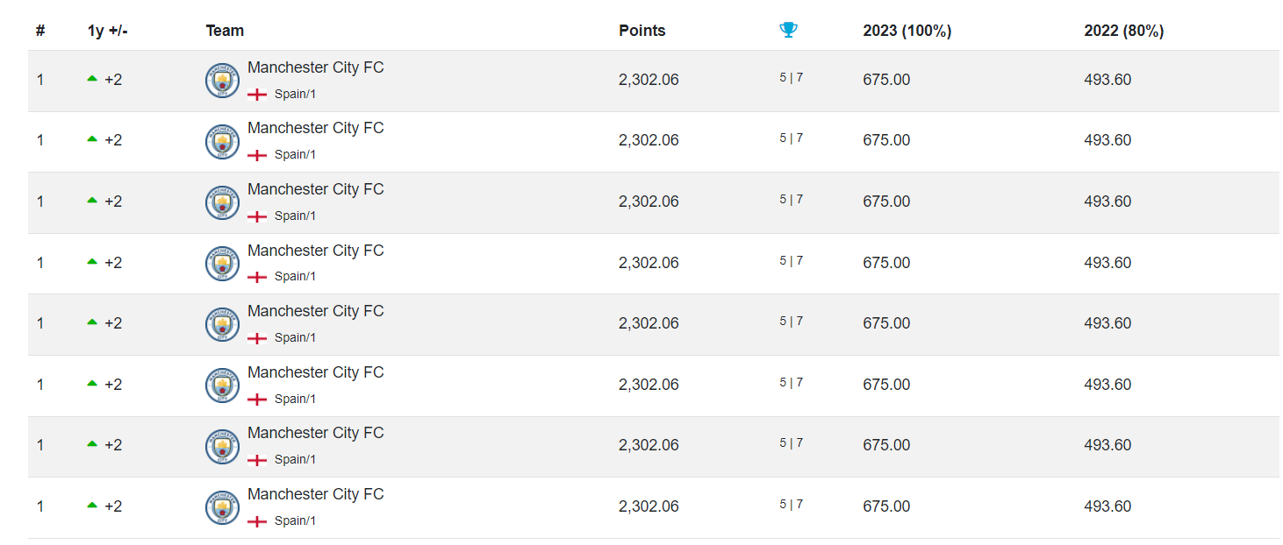

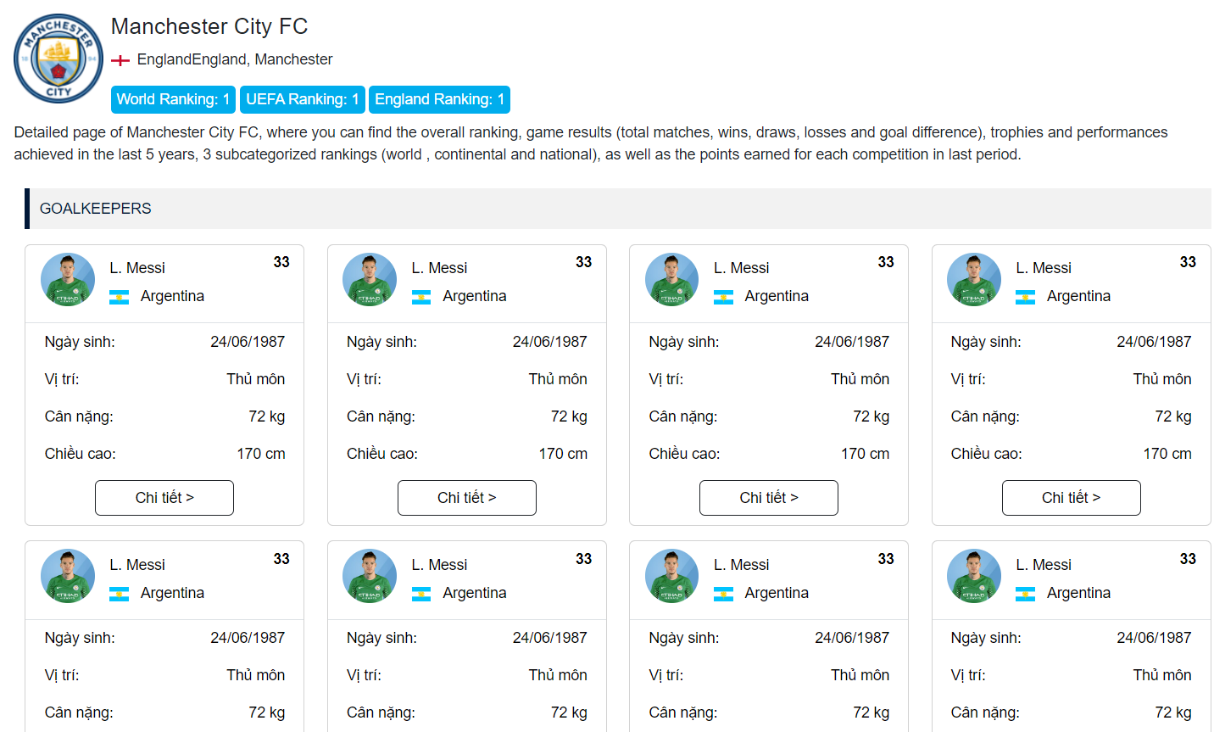

1. **Match**

* Present the match of week and upcoming events.

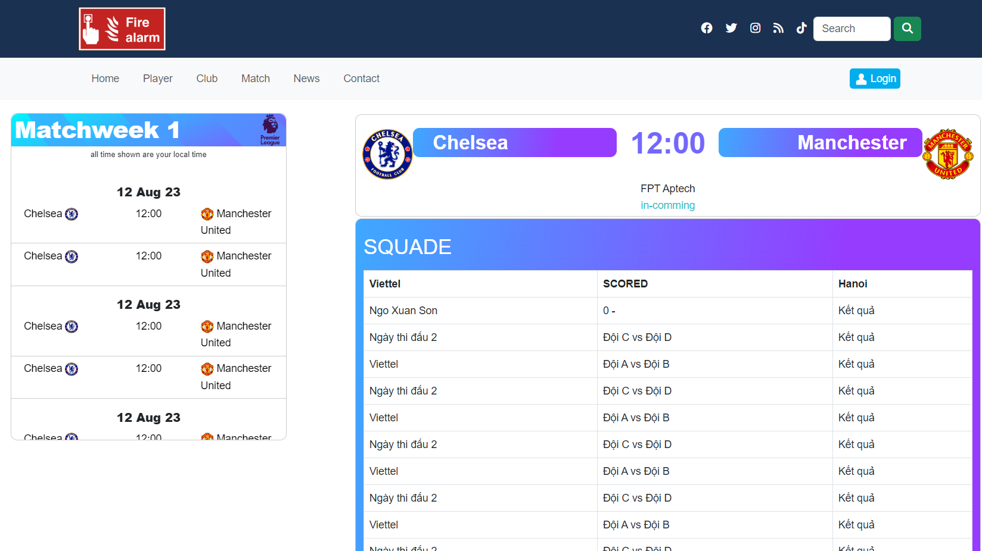

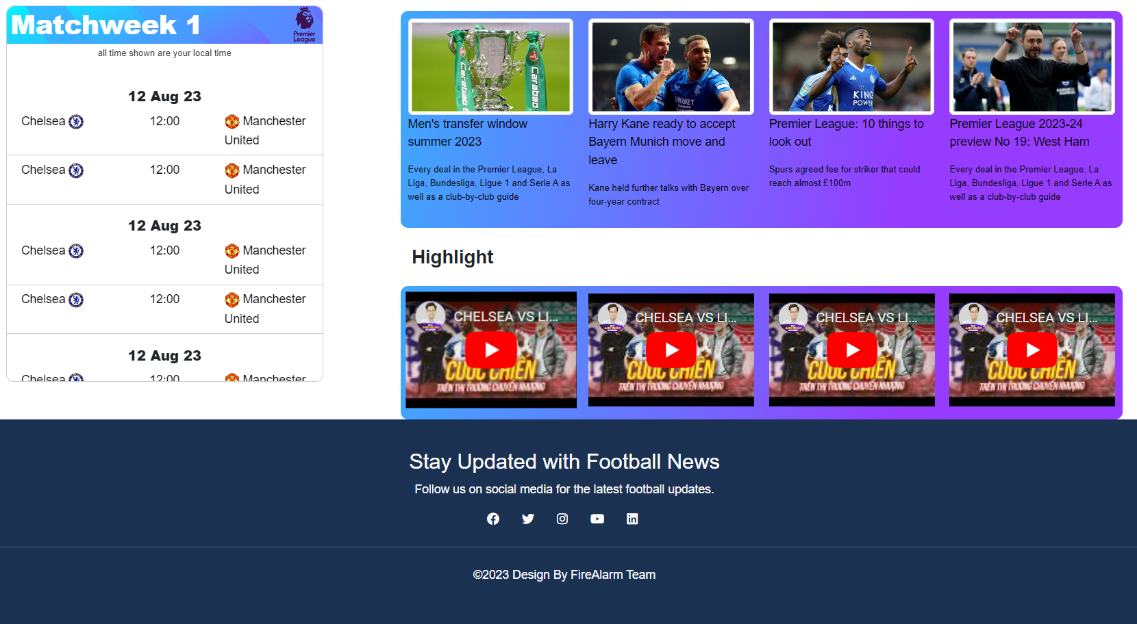

1. **News**

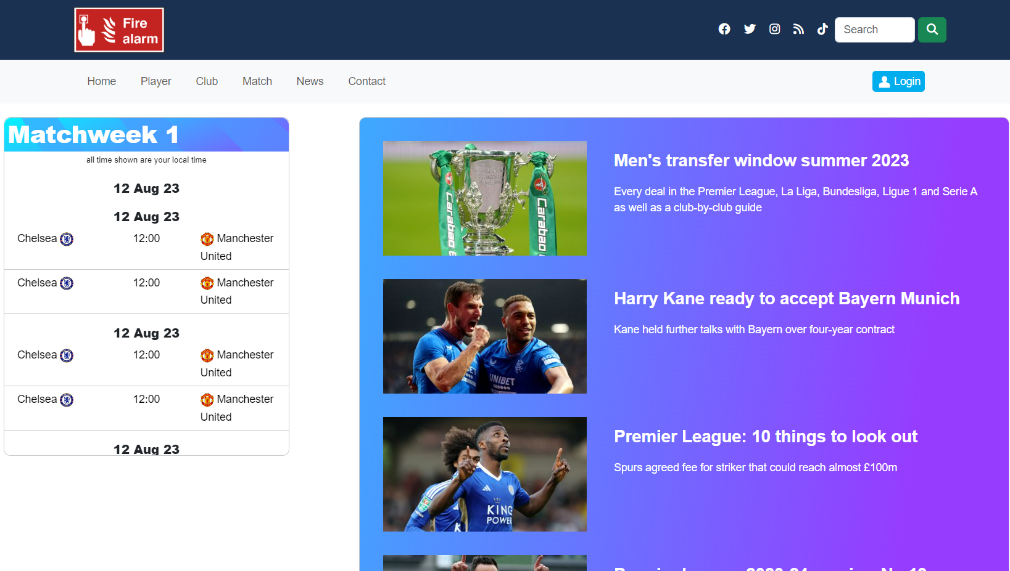

1. **Contact**

* Show a form to send message to administrators.

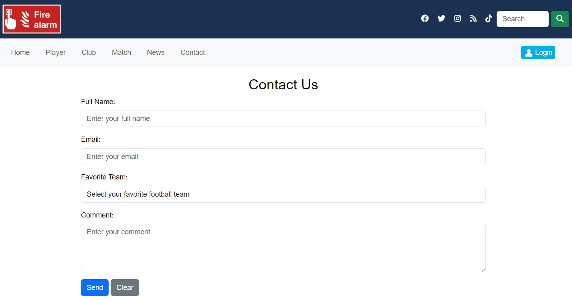

## Test Data

*Website was tested with Desktop and Tablet devices showed well responses.*